Olist Business Review
Notebook-aligned business analysis and HVIA solution proposal
https://prezi.com/craft/?click_source=logged_element&page_location=bottom_cta&element_text=try_prezi_for_free&load=jyauL1SJpytX4xuNdXneHn

Executive Summary
This review reflects the analysis actually implemented in 2-olist.ipynb. The notebook covers data-quality checks, delivery-stage analysis, customer-state delivery performance, payment/order reconciliation, state-level revenue and freight, review scores versus delivery timing, seller-level delivery performance, and a SQL Server export setup.
The main operational signals are: delivery timing varies materially by customer state; the carrier-to-customer stage is a substantial component of total delivery duration; payment totals do not exactly reconcile with item price plus freight for a subset of orders; review scores differ across delivery-status categories; and seller-level delivery-error output can identify candidates for investigation, although low-volume sellers require caution.

Dataset and Method
The notebook loads nine Olist CSV datasets: customers, geolocation, order items, order payments, order reviews, orders, products, sellers, and product-category translation.
The data-preparation workflow checks duplicates and missing values, preserves non-delivered orders when delivery dates are naturally missing, fills selected product and review fields, converts date columns to datetime, and compresses geolocation records by ZIP-code prefix. The notebook then creates order-lifecycle duration fields and joins customers to orders for state-level analysis.
For delivery timing, the analysis uses delivered orders when calculating delivery-stage averages. Delivery-estimation error is calculated as actual customer-delivery date minus estimated delivery date: negative values indicate delivery before the estimate, zero indicates on-time delivery, and positive values indicate lateness.
Review delivery-status categories are created from the same error measure: early (<0 days), on time (=0), late (>0 and <=4 days), very late (>4 days), and unknown when the delivery error is missing.

Analysis and Findings

1. Delivery performance varies by customer state
The notebook groups delivered orders by customer state and calculates average approval duration, approval-to-carrier duration, carrier-to-customer duration, total delivery duration, and delivery-estimation error. The resulting table is sorted by average delivery-estimation error in descending order.
In the notebook output, every state has a negative average delivery-estimation error, meaning average actual delivery was earlier than the estimated date in every state shown. The magnitude differs substantially by state. For example, AL has an average error of -8.03 days, while AC has -20.08 days. Carrier-to-customer duration also varies substantially, from 5.60 days in SP to 25.64 days in RR.

State | Avg. approval (days) | Avg. approval→carrier | Avg. carrier→customer | Avg. total delivery | Avg. estimation error
AL | 0.49 | 2.97 | 21.09 | 24.54 | -8.03
SP | 0.41 | 2.76 | 5.60 | 8.76 | -10.38
RR | 0.40 | 3.35 | 25.64 | 29.39 | -16.59
AC | 0.63 | 2.85 | 17.56 | 21.04 | -20.08

2. Delivery time can be decomposed into operational stages
The notebook separates the order journey into purchase-to-approval, approval-to-carrier, carrier-to-customer, and purchase-to-customer durations. This allows operational teams to distinguish total delivery time from the stage in which time accumulates.
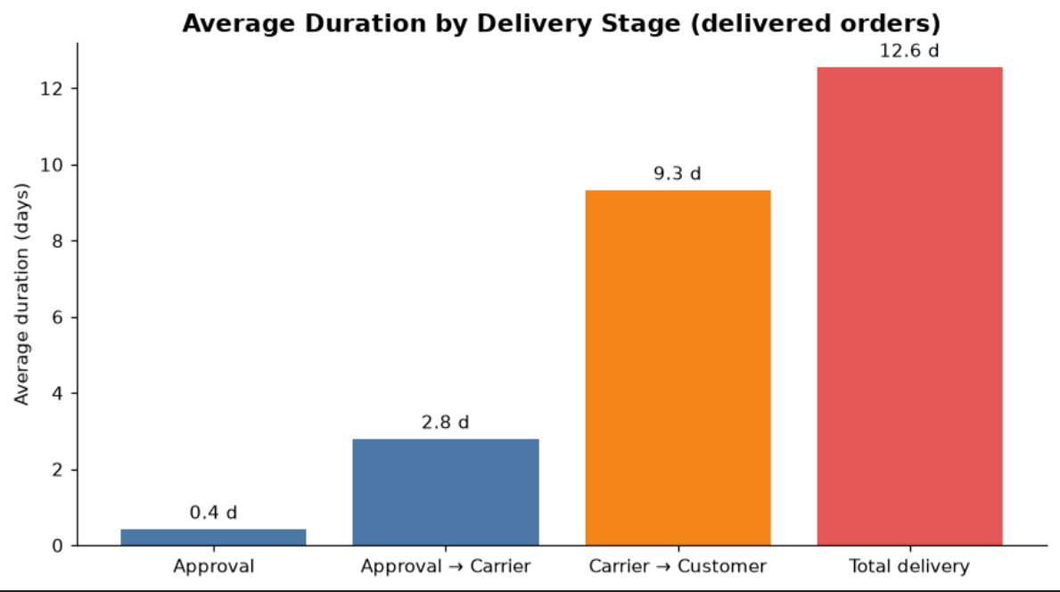
The state-level output shows that carrier-to-customer time is often the largest component of total delivery duration. This makes the carrier-to-customer stage a useful diagnostic dimension.

3. Payment and order totals require reconciliation
The notebook aggregates item prices and freight by order, aggregates payment values by order, defines order_total as items_total + freight_total, and calculates payment_minus_order as payment_total - order_total.
Reconciliation metric | Notebook output
Orders with non-zero payment-minus-order result | 577 rows returned
Total positive payment difference | $3,071.17
Total negative payment difference | -$200.78
Net payment difference | $2,870.39

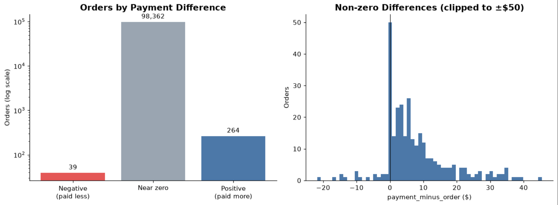
These values are screening signals, not proof of financial loss or accounting failure. Payment structure, multiple payments, rounding, refunds, freight treatment, order status, or data-quality rules should be investigated before treating the net difference as a financial-impact measure.

4. Revenue and freight differ across customer states
The notebook also summarizes product revenue and freight by customer state, including total product revenue, total freight, average freight, freight median, freight standard deviation, and freight coefficient of variation.
State | Product revenue | Total freight | Avg. freight | Freight CV
SP | $5,202,955.05 | $718,723.07 | $17.37 | 0.86
RJ | $1,824,092.67 | $305,589.31 | $23.95 | 0.82
MG | $1,585,308.03 | $270,853.46 | $23.46 | 0.78
PB | $115,268.08 | $25,719.73 | $48.35 | 1.72
RR | $7,829.43 | $2,235.19 | $48.59 | 0.67
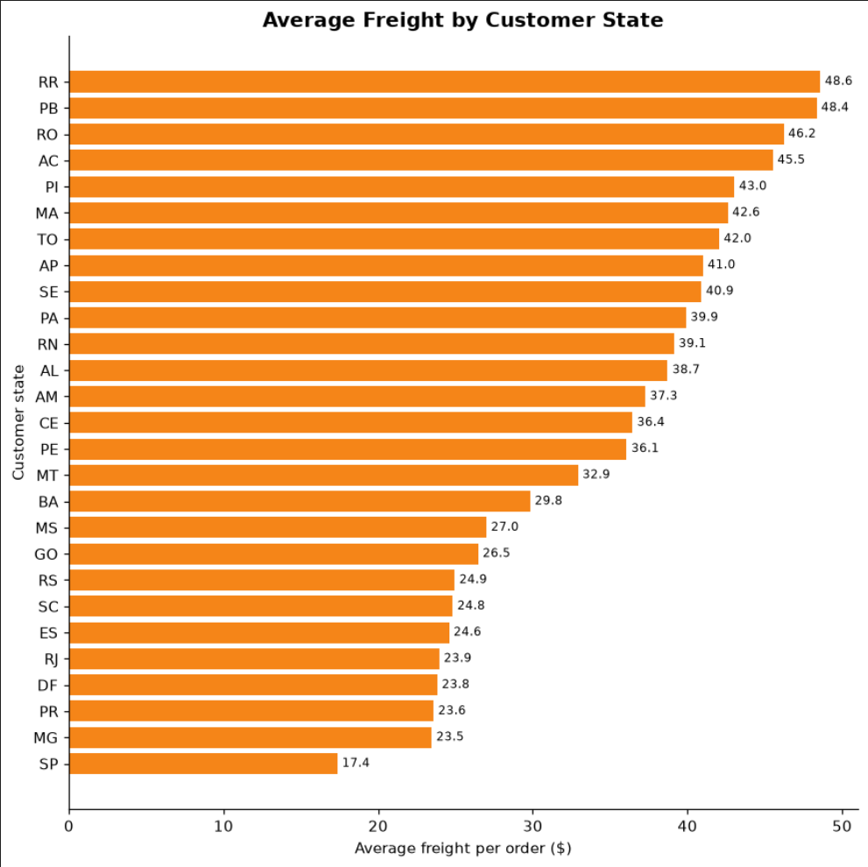
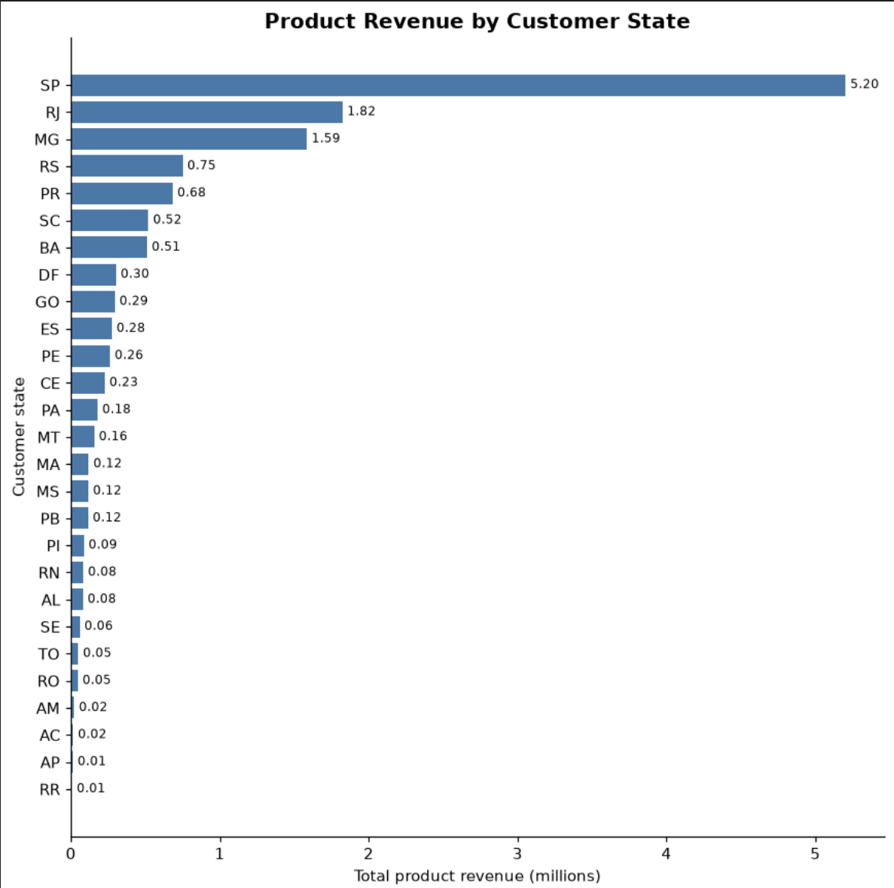

5. Review scores differ by delivery-status category
The notebook first reports the overall review-score distribution:
Delivery status | Orders | Average review score
early | 88,658 | 4.29
late | 3,147 | 3.59
very_late | 4,554 | 1.86
unknown | 2,865 | 1.76

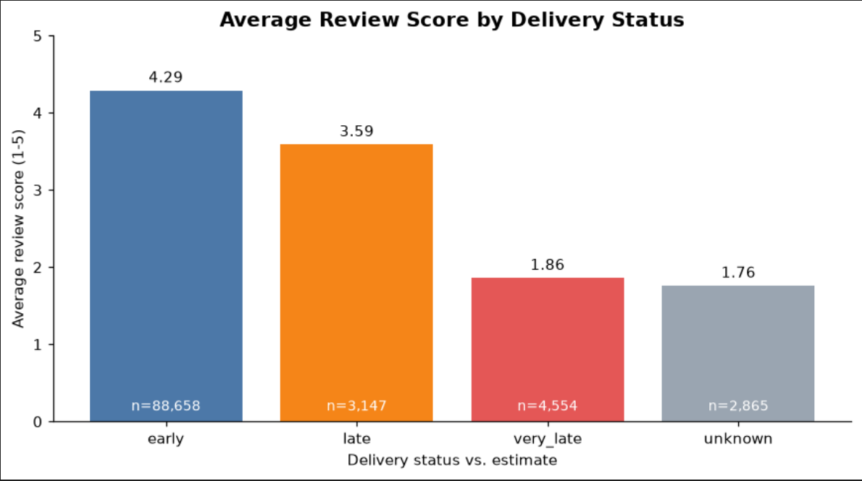
The notebook output shown for this analysis contains no on time row. The unknown category represents orders for which delivery-estimation error is missing, which is consistent with the notebook's earlier handling of non-delivered orders.
Business interpretation: review scores are associated with delivery-status categories in this dataset.

6. Seller-level delivery performance is included
Contrary to the earlier version of this document, the notebook does perform seller-level analysis. It links order items to sellers, keeps delivered orders, calculates each seller's average delivery-estimation error, counts delivered orders, and sorts sellers by average error.
Seller city/state | Delivered orders | Avg. estimation error (days)
farroupilha / RS | 1 | 167.71
sao paulo / SP | 2 | 41.77
juiz de fora / MG | 1 | 35.71
feira de santana / BA | 3 | 33.82
goiania / GO | 1 | 33.81

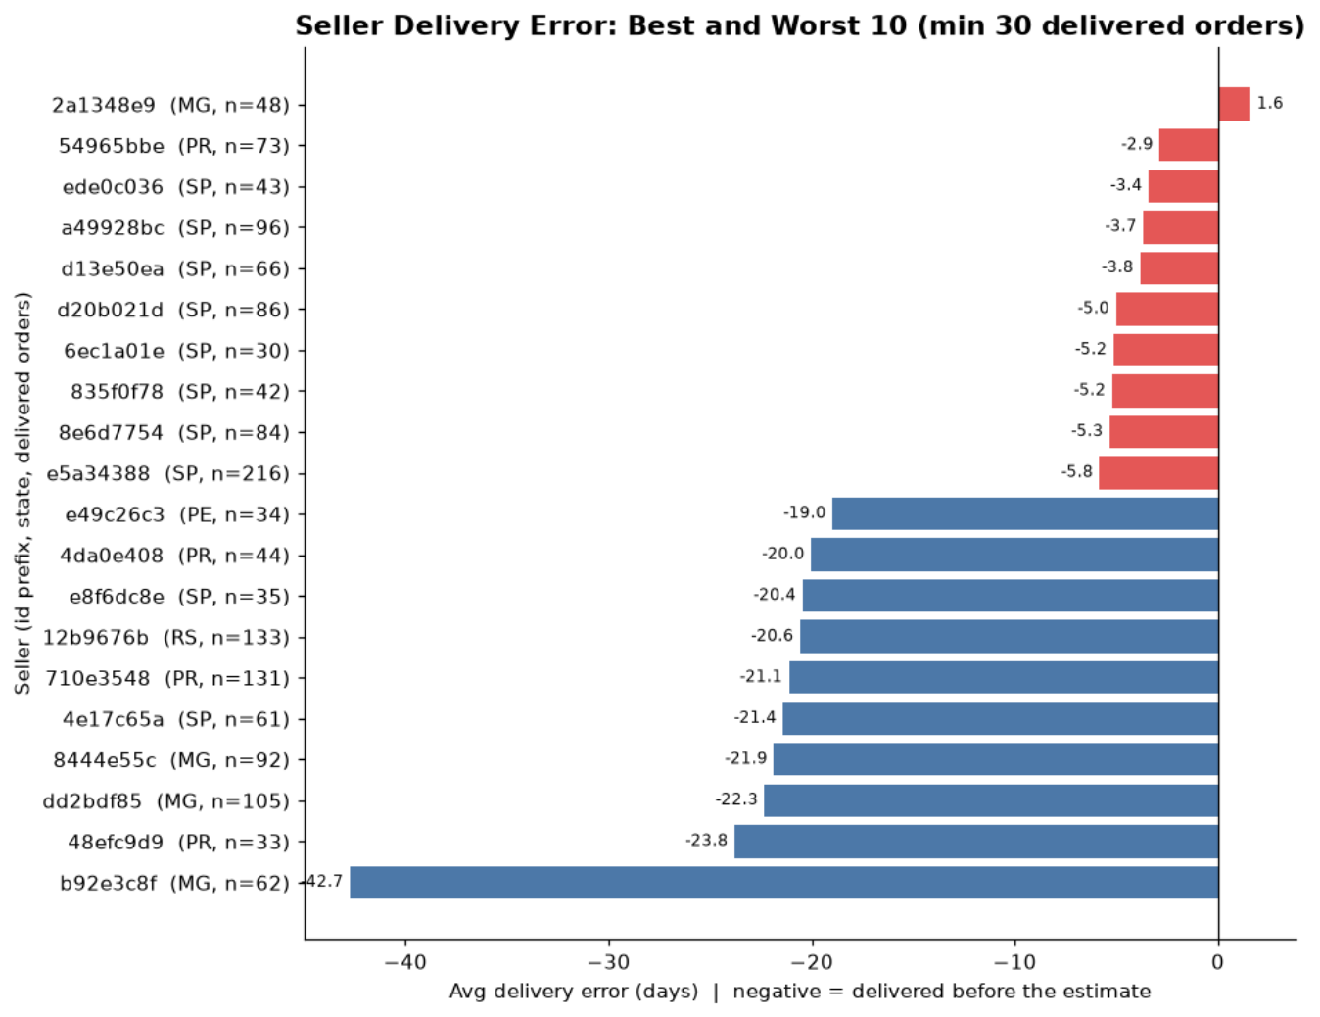

Business Interpretation
Taken together, the notebook provides an operational monitoring foundation across delivery, regional economics, payment reconciliation, customer reviews, and seller performance. It identifies measurable differences and exception cases that can be investigated without claiming causality.
The strongest immediate analytical use cases are: monitoring delivery-stage performance by customer state, investigating payment/order reconciliation exceptions, monitoring review outcomes by delivery status, examining freight variation by state, and screening seller-level delivery performance with appropriate volume thresholds.

HVIA Solution Idea
HVIA could turn the notebook's existing metrics into a governed Delivery and Marketplace Performance Intelligence solution.
- Phase 1: KPI layer: standardize delivery-stage durations, delivery-estimation error, review score, product revenue, freight, order total, payment total, payment deviation, and seller delivery metrics.
- Phase 2: Monitoring: provide dashboards for customer-state delivery performance, carrier-to-customer duration, freight variation, payment/order exceptions, review outcomes, and seller exception lists.
- Phase 3: Controls and enrichment: add minimum-volume rules for seller comparisons, formal reconciliation classifications, and validated definitions for operational alerts.
- Phase 4: Future analytics: after the baseline metrics are validated, extend to review-text sentiment and predictive models for late-delivery or negative-experience risk.

Outreach Draft
Subject: Olist delivery and marketplace performance opportunity
Dear Mr. Dalvi,
I reviewed Olist's marketplace dataset and analyzed delivery stages, customer-state performance, payments and freight, customer reviews, and seller-level delivery performance. The analysis identifies practical opportunities to improve visibility into delivery timing, regional freight patterns, reconciliation exceptions, and customer-experience signals.
HVIA could help turn these measures into a governed performance dashboard, operational monitoring, and a validated foundation for later predictive analytics. Would you be open to a brief conversation about this opportunity?
Best regards,
Mohammad Maher

Supporting Work and Next Steps
Supporting Work: The analysis is based on 2-olist.ipynb, which contains the data-loading, data-quality checks, transformations, exploratory analysis. The notebook analyzes delivery performance by customer state, delivery-stage durations, payment/order reconciliation, revenue and freight by state, review scores by delivery-status category, and seller-level delivery performance.
Next Steps: The next stage should build on the notebook's existing analysis by introducing seller-level monitoring with minimum order-volume thresholds, investigating the causes of payment/order differences, and examining the operational drivers behind regional delivery variation. Further analysis could also extend the review data with sentiment analysis and develop predictive models for late-delivery or negative customer-experience risk after the baseline KPIs have been validated.

